**Data Analysis Report**

This analysis aimed to comprehensively understand the dynamics of student conference attendance, focusing on the financial barriers hindering attendance among medical students. Analysis was done with Python 3.13 pip version 25.1.1 and pandas, scikit-learn, matplotlib/seaborn and wordcloud libraries were used. The insights were derived from quantitative data analysis (including chi-square tests, binary logistic regression, bar charts of attendance rates, and distributions) and qualitative analysis of student suggestions and considerations.

The dataset consists of responses from 49 medical students across Nigeria, focusing on conference attendance patterns and financial considerations. Key variables analyzed include:

* Conference attendance (Yes/No) – Dependent variable
* Expected registration fees – categorical
* Monthly income – categorical
* Geopolitical zone – categorical

Missing values were handled by dropping rows with empty values.

**Descriptive Statistics:**

* Respondents cut across all levels of medical school, but were mostly 400 level students aged mainly 23-26 years old. The data also cut across all geopolitical zones of Nigeria and here were more male participants than females.
* Attendance rate: Approximately 42.3% of respondents reported attending at least one conference
* Income distribution: The majority of students reported earning between ₦20,000 to ₦40,000 monthly, with the highest conference attendance rate among students who earned more than ₦100,000 monthly.
* Expected fees: Respondents most commonly expected conference registration fees less than ₦10,000

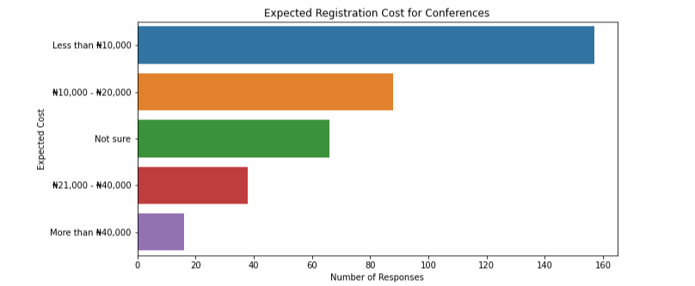

**Crosstab Analysis**:

* Attendance by Monthly Income

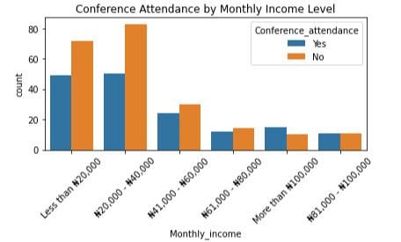

* Attendance rate by Monthly Income

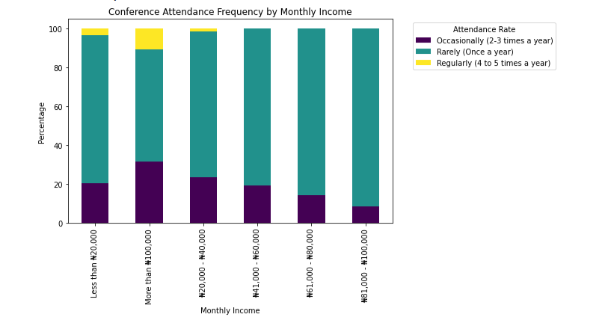

There’s a trend showing higher attendance rates among students with higher monthly income.

* Attendance by Expected registration fee and monthly income

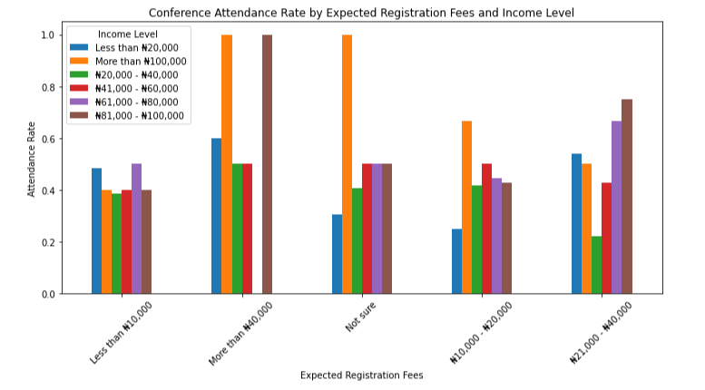

Attendance rates are not uniform across either expected fees or income levels, **indicating a complex relationship**. the chart strongly indicates that **an individual's monthly income level plays a significant role in their conference attendance, particularly in conjunction with their expectations about registration fees.** Higher income levels appear to mitigate the deterrent effect of higher or uncertain fees.

* Attendance by Geopolitical zone

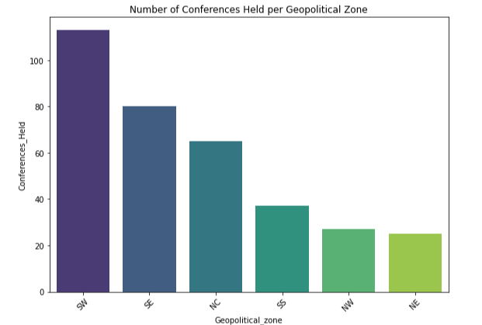

Students attended conferences more in the Southern region of the country (The south west being the highest) and less in the North with the North East. This variation could be due to several factors like population, security, etc.

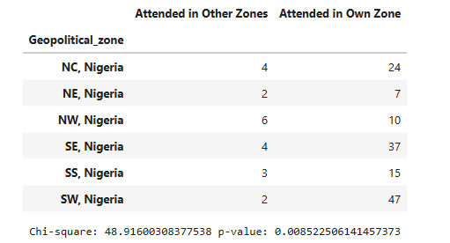

On examining the association between geopolitical zone and whether students attended conferences in their own zone versus other zones, a chi-square test was performed and the results indicated a statistically significant association, χ2(5)=48.92, p=0.009, showing **attendance to conferences is significantly related to a student's preference for attending conferences within their own zone or in other zones. This could be due to accommodation and travel considerations.**

**Financial Constraints Analysis:**

The top four most frequently cited factors are all directly related to the financial burden of attending conferences, accounting for the vast majority of concerns.

* **"Transportation expenses (transportation and accommodation)"** and **"High registration fees"** are the most significant barriers, both cited by 221 and 218 respondents respectively. This highlights that the cost of getting to and staying at a conference is as much of a deterrent as the cost of the event itself.
* **"Lack of funding/support from institution or external sources"** ranks highly with 170 mentions. This indicates that even when students are keen to attend, the absence of financial aid or institutional backing poses a substantial obstacle.
* **"Others"** received only 11 mentions, suggesting that the listed categories cover most common issues.
* **"I'm scared of travelling"** was an almost negligible factor, cited by only 1 respondent. This indicates that psychological or personal travel fears are not a widespread barrier for the student population surveyed.

Also, low income students were more likely to cite these financial challenges as factors hindering their attendance to conferences.

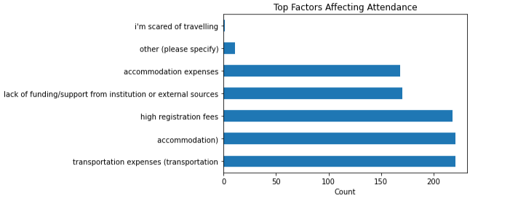

**Logistic Regression Analysis:**

A binary logistic regression was performed to assess the combined effect of expected registration fees for conferences and students’ monthly income on conference attendance.

**Intercept (Log-Odds)**: -0.064

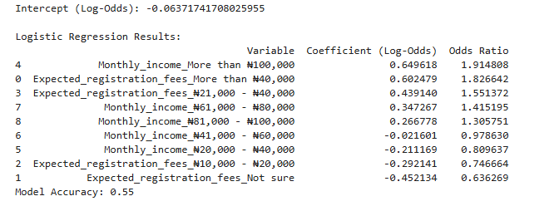

**The logistic regression model was trained on 80% of the data, and tested on 20%. It achieved an accuracy of 55% on the test dataset, meaning it correctly predicted conference attendance outcomes 55% of the time on unseen data. While this indicates some predictive power, it highlights the possible effect of other factors other than registration fees and monthly income on conference attendance.**

**WordCloud Analysis:**

**Respondents’ considerations before attending conferences was analyzed and the word cloud provides compelling evidence that for students, financial implications (registration fees, travel costs, and overall financial considerations) are the most significant factors influencing their decision to attend conferences. Closely following, and serving as key motivators, are the prospects of professional development and networking opportunities. The relevance of the conference content is also considered, but to a lesser extent than the financial and career-related benefits. This analysis suggests that strategies to increase student attendance should heavily focus on reducing financial burdens and clearly articulating the professional and networking value of the conference.**

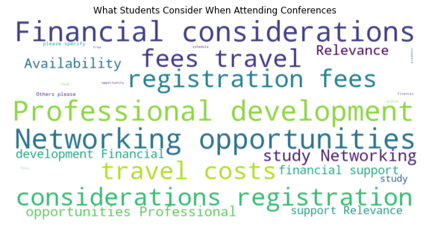

**Key Findings:**

1. **Financial Factors as the Primary Determinant:** Financial considerations emerged as the most overwhelming influence on conference attendance.

* **Dominant Barriers:** The top four reported barriers were exclusively financial: **transportation expenses, high registration fees, lack of funding/support, and accommodation expenses.** These far outweigh non-financial concerns.
* **Income-Driven Attendance Patterns:** Higher income levels, particularly those earning **above ₦81,000 per month, exhibit significantly higher attendance rates**, often reaching 100% even for higher expected registration fees or when fees are uncertain. This contrasts sharply with lower and middle-income groups, who show varied and often lower attendance, especially for higher fee expectations.
* **Attendance Frequency by Income:** While attending "Rarely (Once a year)" is common across all groups, individuals in the **"More than ₦100,000" income bracket show a distinct shift towards "Occasionally" and "Regularly" conference attendance**, highlighting how financial capacity enables consistent engagement.

1. **Dual Motivation: Professional Growth & Networking:** Beyond financial considerations, the analysis of student motivations consistently revealed **"Professional development" and "Networking opportunities"** as the most prominent drivers for attending conferences.
2. **Logistical & Accessibility Challenges:**

* **Location and Frequency:** Students expressed a strong preference for conferences to be held more frequently and in diversified locations, ideally closer to university campuses, to ease travel burdens.
* **Information Dissemination:** There's a perceived gap in the timely and adequate communication of conference information and opportunities to students.

1. **Demographic Nuances:**

* **Gender:** A **statistically significant association was found between gender and conference attendance**, with male students exhibiting a notably higher attendance rate than female students.
* **Monthly Income:** While observed attendance rates varied across monthly income categories, the **overall association between monthly income and general conference attendance was not statistically significant** (though granular analysis revealed increased attendance rate with increased monthly income).
* **Geopolitical Zone:** No statistically significant association was found between geopolitical zone and conference attendance.

1. **Nature of Suggestions:** The sentiment analysis of student suggestions indicated an overall **predominance of positive and neutral feedback**, suggesting a constructive and hopeful tone among respondents, despite significant challenges being highlighted.

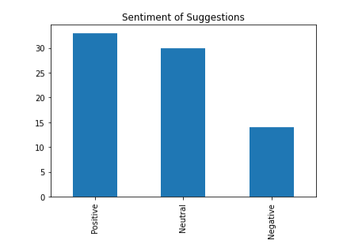

1. A sample of students’ suggestions showed that **lack of funding, institutional support, or personal financial capacity** were major deterrents to conference attendance. Proposed solutions also frequently involved financial relief: free/subsidized conferences, student fee options, grants from NGOs/government, and subsidized accommodation/travel.

**Conclusion:**

The analysis clearly indicates that **financial barriers (registration, travel, accommodation, and lack of external funding) are the primary obstacles preventing students from attending conferences.** While students are highly motivated by professional development and networking, these aspirations are often constrained by economic realities. Addressing these financial and logistical challenges, alongside improving awareness, will be critical to fostering greater and more equitable student participation in scientific conferences.